INDIAN INSTITUTE OF TECHNOLOGY PATNA

CS226- Switching Theory Lab

**Lab 1: Logic simulation basics**

In this lab, you will begin to familiarise yourself with Logisim and simulate some blocks. This will help you learn more about logic, and build the fundamental components used in any digital system.

**Using Logisim**

Logisim is a Java application, it can be obtained from **http://sourceforge.net/projects/circuit/.**

Simply download and run it (tutorial is available help->tutorial).

Exercise : Inverter (NOT gate)

To build a CMOS inverter, you will need the following Logisim components: • A power source. • A ground. • A P-type transistor, facing south. • An N-type transistor, facing north. • A constant generator, to provide an input value. • A probe to read the output value.

If you follow the steps below and build a circuit, you should end up with a working inverter.

1. Place a P-type transistor, facing south, on the drawing area.

2. Place an N-type transistor, facing north, below the P-type. You will notice the P-type has a small round circle at its gate and a directional arrow pointing down, whilst the N-type has no circle, and a directional arrow pointing up.

3. Now place a power component above the top transistor.

4. Next, place a ground component below the bottom transistor.

5. Place a constant component to the left of the transistors (or a pin input), this is equivalent to the input A

6. Place a probe on the right of the circuit. This is equivalent to the output Z

7. Connect the components with wires

(see Figure)

Now, by clicking on the constant component and pressing either the 1 or 0 key on your keyboard, (by clicking on the pin if you used a pin input ) , you can change the logic value that it generates. At the same time, you should see the value at the probe change, in accordance with the logic function NOT. If your circuit does not work as expected, make sure the components are wired correctly, and that the type and orientation of your transistors are correct. If they are not correct, you may see X at the output for a particular input value. Save your work before continuing.

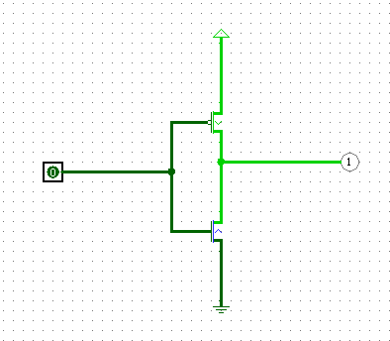

Fig: A CMOS inverter

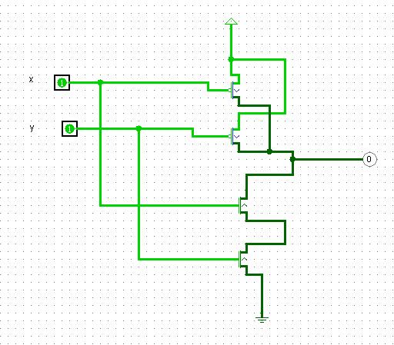

Fig: A CMOS NAND GATE

**Assignment:**

(Design and simulate , verify the truth table for the following).

1. Using the same methods as for the NOT gate, implement a NOR gate using four transistors. Remember to be careful in choosing the correct transistor type and orientation, or the circuit will behave improperly.

**(5 points)**

1. Using the same methods as for the NOT gate, implement a NAND gate using four transistors. Remember to be careful in choosing the correct transistor type and orientation.

**(5 points)**

1. Using the same methods as for the NOT gate, implement a XOR gate using transistors. Remember to be careful in choosing the correct transistor type and orientation. **(10 points)**
2. Using the same methods as for the NOT gate, implement a 3input AND gate . Remember to be careful in choosing the correct transistor type and orientation. (5 points)
3. Using the same methods as for the NOT gate, implement a 4 input OR Remember to be careful in choosing the correct transistor type and orientation. (5 points)

1. Using the same methods as for the NOT gate, implement a XNOR gate using transistors. Remember to be careful in choosing the correct transistor type and orientation. (5 points)
2. Implement NOR, NAND, AND, and OR using NMOS logic. **(15 points)**

**Submission:**

Submit your .circ file containing your various transistor-level/logic level implementations. Submit Report with hand drawn schematic is required for the problemss. Show the simulations to TAs.

* The simulation files p1.circ, p2.circ, p3.circ, p4.circ, p5.circ , p6.circ and P7.circ
* Zip the above five files. Zip file name is your role number.

Course work submission through Email: [cs225.iitp@gmail.com](mailto:cs225.iitp@gmail.com)

(use email subject Lab1_Logicsim_your roll number).

This work should be completed in class.